EDU 270: Comparative Education in Belize 
Jill Heinrich, Ph.D.
Cornell College

Term 6 – February 11th – March 6th, 2019
_______________________________________________________________________________________________________________________________________________________________________________

Instructor: Jill Heinrich, Ph.D. Classroom: College Hall 303
Office number: College Hall, Room 106 Office phone: 895-4352 E-mail:j1heinrich@cornellcollege.edu
Jill’s cell phone: (319) 330-7149

Flight info: one suitcase no more than 50 lbs & 1 carry-on. No liquids in carry-on over 4 oz. Electronics must be able to be powered on when going through security. Don’t pack anything of value in your suitcase as it will be susceptible to theft and not covered by airline insurance.

Class time varies each day so please note specific dates and times on the course syllabus; also I will call periodic meetings while we are in Belize as needed.

Course Objectives:

To gain an understanding of Belizean culture, of the diverse groups that comprise this society including Hispanic, Mayan, Mestizo, Creole and Garifuna peoples.

To gain a deeper understanding of the ways in which European colonialism has shaped Belize’s history and its people since the 17th century.

To gain first-hand knowledge of and experience in a Belizean school system through a sustained practicum experience.

To develop understanding of the ideological and procedural differences between the Belizean school system and the U.S. system.

To recognize the fundamental differences between the U.S. school system and the Belizean system in regard to separation of church and state in the realm of public education.

To understand how qualitative inquiry can be employed to gain insight into the particular to better understand the general.

To complete a major qualitative research project that constructs meaning of the student’s idiosyncratic off-campus experience and that offers unique insight to the field through the verisimilitude of individual portraits and experiences.

Course Readings: All posted on Moodle so download electronically or print before we leave campus.

Merriam, Sharan B. (1998). Qualitative Research and Case Study Applications in Education. San Francisco: Jossey- Bass.
ISBN-13: 978-0787910099 ISBN-10: 0787910090 Edition: 2nd Revised & Expanded

.

Attendance and Participation
Practicum/Participation Grade: Any absence from the school practicum must be made up on the last free day. Two or more absences will likely result in no credit for the class unless there are extenuating circumstances. Be a considerate guest: PLEASE make sure your cell phone is silenced when you go to school and refrain from ever using it in the classroom. Also, do not take an IPAD or laptop with you to school unless it is requested from the teacher. Remember that we are guests in these classrooms and should be grateful and show respect at all times to both the teacher and the students.

Assignments

All assignment due dates are noted on the syllabus. Assignments are due at the beginning of class, and late assignments will be reduced a letter grade for each day they are late. Please see individual assignment sheet for complete details.

School Practicum Experience & Field Notes: your teacher will complete an evaluation of you. If you miss practicum for any reason, you must make up the absence on the last day which is a free day for the class.

Field Notes & Daily Reflections: Daily field notes should be kept in a notebook. Students should also write three weekly reflections that will be collected on Friday.

Qualitative Research Paper: course paper will be due on Wednesday, March 8th.

Course Details:

Carnival: Carnival will be celebrated the 1st weekend we are there; as part of this tradition, children paint adults (with consent) so if you would like to participate, bring some old clothes and flip flops.

Assignments: All reading and written assignments should be completed prior to class; late assignments will be lowered a letter grade for each day they are late. If you would like to discuss a grade with me, please make an appointment to meet during my office hours. I will be happy to meet with you outside of class to provide assistance and direction for course assignments, particularly for the course paper; however, I simply cannot read course papers prior to assessment.

Academic honesty: Any student found to engage in academic dishonesty (this includes plagiarism and submission of materials written secured from other courses, students, the internet, etc.) should expect to receive a failing grade for the course. Please refer to the Academic Policis on http://cornellcollege. edu/student_affairs/handbook/. Any form of academic dishonesty will be reported to the Dean’s Office, and please know that it can result in denial of admission to or removal from the Department of Education’s Teacher Preparation program.

Course Schedule: Depending upon our involvement in the Belize schools, we will likely have to alter the course schedule; we will discuss this as a class and determine class time accordingly.

Special Accommodations: Please inform me on the first day of the block of any special needs you might have that might interfere with your learning experience in this course so that I can make arrangements to facilitate your needs. Should you make a request, I will contact the Registrar’s Office for verification.

15 Day Withdrawal: Students have the option of withdrawing on the 15th day without grade penalty; however, this withdrawal must be approved by me, and the decision will be based upon both attendance and effort.

Grade Incompletes: The Registrar’s Office requires medical documentation for any incomplete grade. Should you need to request an incomplete for the block, please know that you must provide medical documentation.

Site: San Pedro Island, Ambergris Caye, Belize

Lodging: Isla Bonita Yacht Club 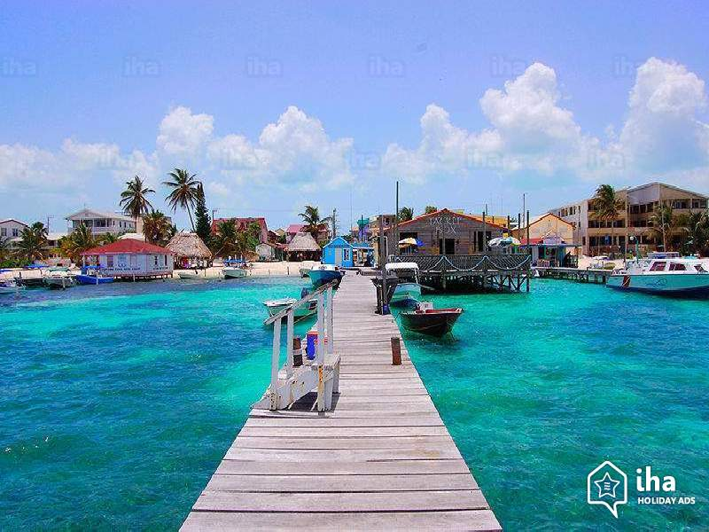

Schools: Ambergris Caye Elementary School (ACES) Principal: Ms. Denice Ryan Assistant Principal: Ms. Amanda Lopez. Isla Bonita, Principal Ms. Addy Martinez. The Island Academy, Ms. Wilema Administrator, owner Lady Dixie Bowen.

Meals: Groceries are expensive but you can get whatever you need in San Pedro. I suggest taking some snacks such as energy bars, nut mix, etc.

Breakfast: will be on your own, and there are a few great bakeries on the island where you can pick things up.

Lunch: on school days, you can purchase home-cooked, excellent meals for a nominal price at ACES or take your own lunch.

Dinner: I will provide several dinners; sometimes we will go out as a group, and other times I will provide carry-out such as pizza, BBQ or sandwiches. On the nights we are getting carry-out, you are free to dine out instead at your own expense and I can provide several options. If you choose to dine-out on these nights, please let me know in advance.

Packing: sunscreen (spray and lotion), bug spray with deet, hat, water bottle, bag or backpack to transport items to school, GOOD walking shoes, snacks, any medications (you will be on boats so decide if you need Dramamine).

Jewelry: do not take any jewelry you will not be wearing at all times

Valuables: I would try to limit what you take but take what you need. The condos lock and there is a safe in the room so put all valuables and cash in the safe.

Laptop: the condo does have internet.

Credit cards & ATM: make sure you have notified both of a travel advance. Also, do not get cash from an ATM unless it is located in a bank to avoid fraud. Be careful of readers on other ATM’s.

Our course has been approved as part of the college’s Ingenuity in Action Program, and so you will be participating in this pilot program. We will discuss the advantages and process of this participation in class, but listed below is a brief synopsis about the program as well as the links for the application and the final reflection.

Cornell College’s “Ingenuity in Action” Pilot Program

The "Ingenuity in Action" program provides guided opportunities for students to document and reflect on their educational experiences. Completed experiences are documented on a student’s academic transcript in addition to any course credit earned.
This course has been pre-approved as meeting the expectations and requirements of the category of Global Connection.

If you are interested in participating in this program, you should submit an application. In your application, you will need to select the appropriate category and provide contact information for you, your academic adviser, and your sponsor. After the completion of the course, you will need to complete and/or upload a final reflection for review by your sponsor and the Experiential Learning Program office.

The application link is: https://cornellcollege.presence.io/form/proposal-form
The reflection link is: https://cornellcollege.presence.io/form/reflection-form
.
For more information about the program, please contact Jen Barnes, the Experiential Learning Program Project Coordinator (jbarnes1@cornellcollege.edu) or Devan Baty, Faculty Director (dbaty@cornellcollege.edu).

Course Readings

Day 1 2/11 Class meets 9:00 – 11:30 and 12:30 – 2:30
Monday Introduction to course and explanation of assignments and expectations
Discussion of cultural considerations & carnival (bring old clothes & flip flops)
Anna Butz: 9:00 a.m. to collect paperwork; Jen Barnes Ingenuity in Action 9:00 a.m.

Day 2 2/12 Class meets 9:00 – 11:30 and 12:30 – 2:00 (afternoon meeting only if needed)
Tuesday Moodle: Merriam: Chapter 1 “What is Qualitative Research”
Divide supplies and books to be transported to Belize
Check in for flights (bring copy of your passport to class)

Day 3 2/13 Depart for Belize: Airport shuttle will pick you up at the top of the Commons Circle at 4:30 a.m.
Walking tour of island & visit to the store to stock up & bank for cash withdrawal
Dinner: Neri’s Tacos & Roadkill for Karaoke (yes everyone has to sing)

Day 4 2/14 Class: 9:00 a.m. to visit all three schools: Island Academy, ACES & Isla Bonita.
Thursday Afternoon in schools
Merriam Chapter 2 “Case Studies as Qualitative Research”

Day 5 2/15 All day at school site
Friday Class meets at 5:30 at Jill’s condo to meet our island friends-Lily, Joshua, Hilda & Jordy
Group Dinner: Blue Water Grill 7:30 p.m. (nicer dress for this restaurant)

Day 6 2/16 Carnival: painting on the beach at noon
Saturday Dinner: on your own (see Jill’s list of restaurants)

*tomorrow will be a long and rigorous day so rest up tonight. Also, you will be on several boats so if you get seasick, you may want to bring Dramamine.

Day 7 2/17 Day trip: to Lamanai Mayan Ruins
Sunday Bring: sunscreen, hat, bug spray, wear good shoes to walk & climb
Dinner: on your own

Week # 2

Monday – Friday you will have practicum all day unless otherwise noted

Day 8 2/18 Practicum - all day at school site
Monday Merriam - Chapter 5 “Being a Careful Observer” pp. 94-111

Day 9 2/19 Practicum – all day at school site
Tuesday

Day 10 2/20 Practicum - all day at school site
Wednesday Moodle: Merriam – pp. 152-161

Day 11 2/21 Practicum morning only; afternoon class
Thursday Merriam - Chapter 9 pp. 179-197
Visit to Holy Cross School in the San Mateo district
Discussion with Island Pharmacist about healthcare issues on San Pedro

Day 10 2/22 All day practicum
Friday

Day 12 2/23 Day Sail: Hol Chan Marine Reserve & Shark Ray Alley
Saturday Depart: 7:00 a.m. – they will pick us up at the dock
Trip: wear swimsuit, bring sunscreen, hat, towel & money if you would like to shop on Caye Caulker

Day 13 2/24 Individual meetings with Jill to hone research question
Sunday

Week # 3

Day 14 2/25 All Day Practicum
Monday Moodle: Read Merriam – Chapter 10

Day 15 2/26 Day to explore the island or visit school again for interviews
Tuesday Class meets 5:00
Farewell Dinner: Hidden Treasures

Day 16 2/27 Departure home - taxi will take us to the airport at 10:00 a.m.
Wednesday Arrival in Cedar Rapids at and shuttle will take you back to campus.

Day 17 2/28 Class meets 1:00 – 3:00
Thursday Workshop course papers

Day 18 3/1 Class meets 9:00 – 11:30
Friday Workshop course papers

Week # 4

Day 19 3/4 Class meets 9:00 – 11:00 and 1:00 – 3:00
Monday Qualitative Paper presentations
Write trip reviews to help vendors we worked with & restaurants

Day 20 3/5 Class meets 9:00 – 11:00 and 1:00 – 3:00
Tuesday Qualitative Paper presentations

Day 21 3/6 Final course paper due by noon
Wednesday Application & final reflection must be completed and uploaded for the Cornell
Ingenuity in Action Program

Rooming:
Studio Condo: Taylor Wussow, Kyra Ford & Emily Sorem
Studio Condo: Matt Renaud, Brady Tobin & Anthony Manning
Apartment: Ashley Queseda, Annika Birk, Katie Wycoff, Stefany Cruz, Madison Charles & Dylan Davis

Field Trip Excursions: Tuff Enuf Tours LeRoi – phone (501) 660-3647 tuffenuff.cdm@gmail.com or tuffenuf@btl.net

Cell phone numbers: 

Jill Heinrich (319) 330-7149

Annika Birk _____________

Madison Charles _____________

Stefany Cruz _____________

Dylan Davis _____________

Kyra Ford _____________

Anthony Manning _____________

Matt Renaud _____________

Emily Sorem _____________

Brady Tobin _____________

Ashley Queseda _____________

Taylor Wussow _____________

Katie Wycoff _____________

 Shuttle to Cedar Rapids Airport:

The shuttle will pick you up at the top of the Commons Circle at 4:30 a.m. so please be on time. I will not be there as I’ll be driving from Iowa City to the airport. If you miss the shuttle, you will have to drive yourself to the airport and pay for parking. The shuttle will also take you back to campus when we return home.

Airfare Information: American Airlines 
Record Locator: NQMUIY

CID # 4112 DFW # 2451 BZE

7:15 a.m. 9:41 a.m. 1:59 p.m.

Details: you can check in for your flight 24 hrs. prior and print your boarding pass or have it sent to your phone. You will need your passport # to check in. Please check in prior to save time at the airport; however, you will still need to go to the American desk to show the agent your passport, and if checking a bag, you will do so here. Cost is $ 30 each to check a bag (each way) and it must be under 50 pounds (keep your receipt because if we have enough money at the end of the trip, we will reimburse you). You are also allowed a carry-on but make sure its size complies.

BZE # 926 DFW # 4113 CID

3:41 p.m. 6:55 – 9:11 p.m. 11:04 p.m.

Return flight – be ready for the taxi at 10:00 a.m.

Tropic Air flights 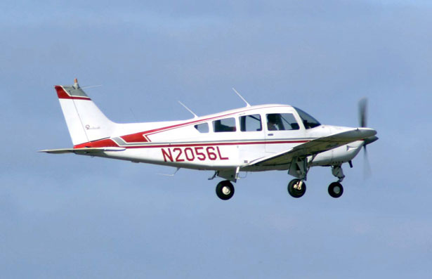

Wednesday, February 13th 14:40 (2:40 p.m.)

Wednesday, February 27th 11:00 a.m. (be ready to go to the airport at 10:00 a.m.)

Arrival in Belize City: we’ll immediately go through Customs and then collect our bags and go through security. Make sure that you don’t put ANY valuables in the baskets such as watches or jewelry; put them inside of a bag instead. Once we get through security with our luggage, we’ll take the flight on Tropic Air to San Pedro.

School Placements 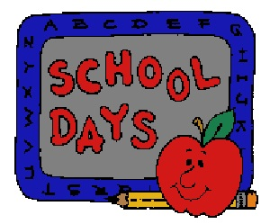

La Isla Bonita Elementary School
Website: https://ambergriscaye.com/labonita/index.html

Ms. Addy Martinez, Principal cell (501) 633-2009
Eight classes - Infant to Standard VI. Eight students may be placed here.

Ashley Quesada
Annika Birk
Katie Wycoff
Stefany Cruz
Madison Charles

Ambergris Caye Elementary School (ACES)
Website: https://ambergriscayeelementaryschool.webs.com

Ms. Denice Ryan, Principal denicelr@aol.com
Amanda Lopez – teacher mrs_alz72@hotmail.com phone: 011-501-650-5263

Has 6 classrooms and will take 7 students. This is a private school that goes through 8th grade.
Hours: 8:30 – 12:00 and then 30 min. lunch 12:30 – 3:00

Matt Renaud
Dylan Davison
Taylor Wussow
Emily Sorem
Kyra Ford

The Island Academy
Website: https://theislandacademy.com

Lady Dixie Bowen - Founder and Director
Ms. Wilema Gonzalez - Executive Administrator

Brady Tobin
Anthony Manning

Restaurants: 

Carry-out/Bakeries:

Delices De France Bakery: Johnny Grief Drive, Sancas Plaza (closer to airport). Great French bakery for baked goods and sandwiches.
Ruby’s Café: great baked goods & sandwiches carry-out. Try the Johnny Cakes!!!
My Secret Deli – by Paradise Villas. Students have really liked this in the past.
The Baker: Seagrape Drive south by ACES. Good sandwiches, baked goods and smoothies.
Pepperoni’s pizza – can eat there outside or have pizza delivered; best pizza on island
Grilled burgers: there is a lady who grills great burgers right before the bridge in front of the hardware store and the grocery store.
Annie’s – pastries. Just across the bridge on your left.
DandE –best ice cream in town!!

Casual/Take Away:

Ruby’s BBQ – in town on Sunday
Neri’s Tacos: casual, outdoor & very cheap. Located on back street.
Robin’s Kitchen – outside Jamaican BBQ stand, south by ACES; and chicken and BBQ
Celie’s Deli – in town

Dine in:

Ammore Pasta – 445 Coconut Drive South. Reasonably priced, good pasta.
Mesa – Vilma Linda Plaza, Tarpon street. Great café for breakfast and lunch.
Caramba’s – in town Mexican
Caliente – Mexican – hosts the famous Chicken Drop. Beachfront at the Spindrift Hotel, Barrier Reef
Latitude’s Café - Black Coral Street, on beach. Good breakfast & lunch – closes 4:30
DJ’s – best burgers south of bridge
Estel’s Dine by the Sea: good breakfast, lunch and dinner. On the beach.
Miss Caroline’s – by airport. Very good food & moderately priced.
Waraguma – local, cheap eats. Located in town.
Wild Mango’s – Barrier Reef Drive (on the beach). great food at different price points.
Blue Water Grille - Barrier Reef Drive (on the beach; good food a bit more expensive.
Stellas Sunset – haven’t been here yet but gets good reviews.
Croc’s Sports bar –bar and grill across the bridge, fun place for hanging out in the sun.
The Coconut Café – Coconut Drive. Haven’t been here but gets great reviews. Located at Brahma Blue resort. Breakfast, lunch & dinner.

